Sample program output if user choose the **Comedy** radio button, the system displays the Alert confirmation dialog box as follow. Pls refer <https://code.makery.ch/blog/javafx-dialogs-official/> for the Alert confirmation dialog box.

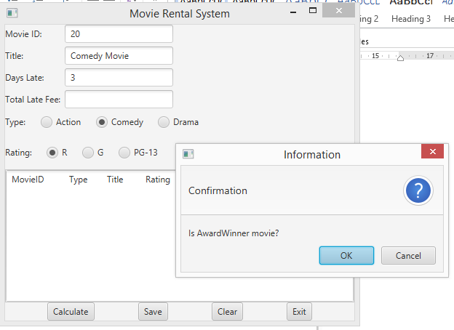

After user clicked on Ok button, the program will output

